January 11th, 2009

Hi

Not much to write about. On Friday, I was up at 4:00 am to get the first hotel bus at 5 am to go to the airport to see Nadine. We had a good time for 3 hours when she had to leave for her flight to New York. I followed the flight path of her ‘plane and, yes, it did fly eastwards across the Northern Pacific and Northern Canada. By doing this, it would catch one (or more) of the jet streams, which blow from west to east. Received many bags of MINTIES from her. On the inside of each wrapper is a cartoon meant to reflect the slogan, which they have had as long as I can remember “It’s times like these you need Minties!”
My injured heel is taking a long time to heal. In the two 30-min runs in the gym this past week, I got back to my average speed and even did about 10 minutes without holding on. Because I this, I decided to go for a hike/run yesterday. I don’t know if this was a good idea or not. I stayed on even paved roads for most of the run to avoid twisting my ankle. The run was a bit difficult, slow with only about half actually being run and there was a lot more walking towards the end. So at 2 h 25 min, it was a bit longer than I was expecting. It also seemed to exhaust me – I guess injuries require a lot of energy to recover. I dozed most of the afternoon, while trying to read Time magazine, then went to bed at 9 pm and stayed there for 13 hours! except for getting up to gargle (see below).
Talking about Achilles tendon injuries, I saw a few minutes ago on the Planet Rugby website that Daniel Carter injured himself again with a recurring Achilles tendon injury. I understand what he is going through! A ‘simple’ injury, such as this, can put top-flight players out of action for good. (In case you did not know, he is playing for a club in France for 6 months on a very lucrative contract.)

On Tuesday, when I arrived at the gym, I met Prem. Do you remember/know him? He told me that it was his last day! He resigned now instead of probably being laid off later because of hotel retrenchment. By doing so now, he said he could get better terms. He also mentioned that new accommodation leases have been reduced a little, having gone up about 20% a year ago; a reflection of harder economic times.
Cooler and drier weather at the moment – perfect for grass fires. One fire yesterday raged for about 8 hours before it could be brought under control. The maximum temperature on my run yesterday was about 13⁰C, so it was pullover-wearing condition.
My body seems to be packing up! What with the Achilles tendon injury and mysterious illness a couple of weeks ago. Now my tongue is very painful. I burnt it last week eating a sweet corn that was too hot. Then I bit the same spot with my teeth (biting my tongue or lip is a regular occurrence). Finally, starting on Friday evening, I got a very sore throat (left side only). So I have been gargling with hot salt water, which wasn’t easy because of the damaged tongue! So, last night I was up a couple of times to have a gargle. How did I get a sore throat – was it at the airport from the sore throat you had, Nadine?

Did you hear about the 19-year old girl in Beijing who died the other day from bird flu? While having a break in her home village, she had been handling the innards of ducks, from which she picket up the H5N1 virus. In HK, the Caritas Medical Centre, which recently ignored the man outside its doors having a heat attack, went on a major emergency alert the other day. Why? Because a visitor in the entrance lobby fainted!

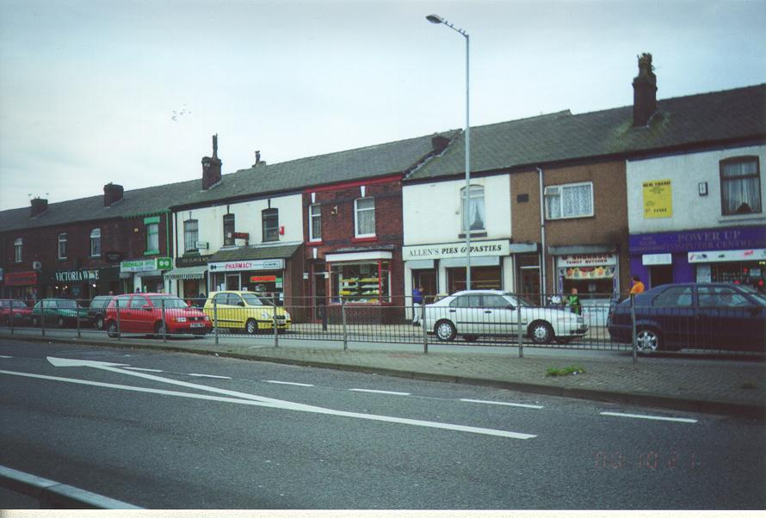
Yesterday, I got a letter from Janice. She mentioned that she, Bob, Wendy and Brian spent several weeks in England last year. They took a barge along the Leeds and Liverpool canal through parts of Lancashire and Yorkshire. Maximum speed allowed – 3 mph! They also spent some time in the Bolton area digging up more on earlier generations of Heyworths. Janice has actually done a lot of research into the family tree and many years ago produced a book on it, a copy of which I saw once while in Christchurch. The picture above is one of mine. I think, but am now not 100% sure, that my grandparents lived in the house with the white façade behind the lamppost. Can you remember going there?
That’s about it for now.

Cheers

